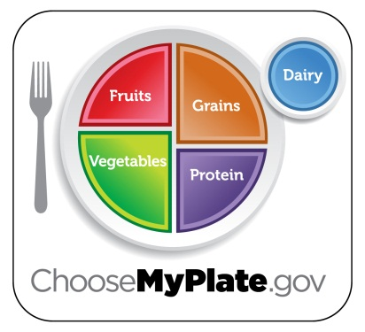
ChooseMyPlate Website Project
Nutrition & Wellness
Task: To discover what foods you consume and how much physical activity you should do for a healthy lifestyle.
Steps to complete the task:
- Go to the ChooseMyPlate website- a link is provided on the course page
- Click on SuperTracker- can be found under popular topics or in green SuperTracker & Other Tools heading at the top
- On the SuperTracker page, you will need to create a profile and save to register your profile for upcoming tasks
- Print off your results for your personal plan to include with your project
- Go back to the homepage, click on 10 Tips Nutrition Education Series under popular topics. Then click on the first link- Choose My Plate
- Read through the 10 tips for Choose My Plate. As you read and write down key points on the ChooseMyPlate 10 Tips worksheet under each tip. The worksheet is provided under the document links on the course page. After opening, save it to your drive and type your answers. Print off to include with final product.
- Track the food you eat for one day- record on a scratch sheet of paper
- Then on the website, click on Food Tracker- can be found in green headings at top of page
- Enter the foods your recorded in #7
- Submit when finished entering foods and it will analyze how you did according to your personal daily food plan. Print your results to include with your finished product.
- Back on the website, click on Physical Activity tracker- can be found in green headings at the top of the page
- Enter the physical activity you typically do and then click on submit. Print the results to include with your finished product.
- Navigate back to the Food Tracker. This time plan a menu (breakfast, lunch, supper, snacks) for 1 day that meets the required amounts for each food group. Use the bar graph to help you make sure you are getting the required amounts. Shouldn’t go over or be under. Print off sample menu when finished to include in your final product.
- Complete ChooseMyPlate Reflection Questions worksheet- worksheet can be found under document links on course page. After opening, save it to your drive and type up your answers. Print off to include with project.
- Turn in finished project into Mrs. Endorf stapled together in the following order:
  - Daily Food Plan Results
  - Choose My Plate 10 Tips Worksheet
  - Super Tracker Results
  - Physical Activity Tracker Results
  - Food Tracker Menu Plan Results
  - ChooseMyPlate Reflection Questions

